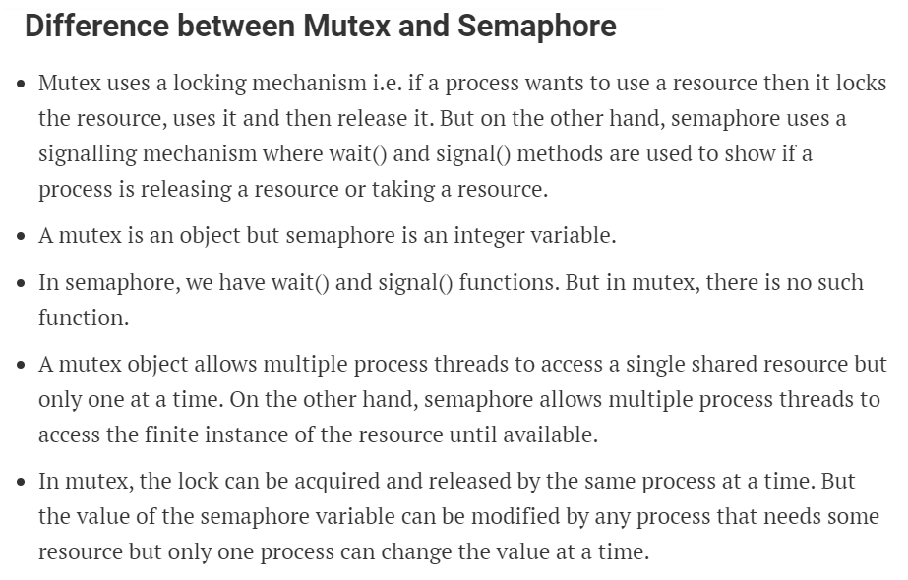

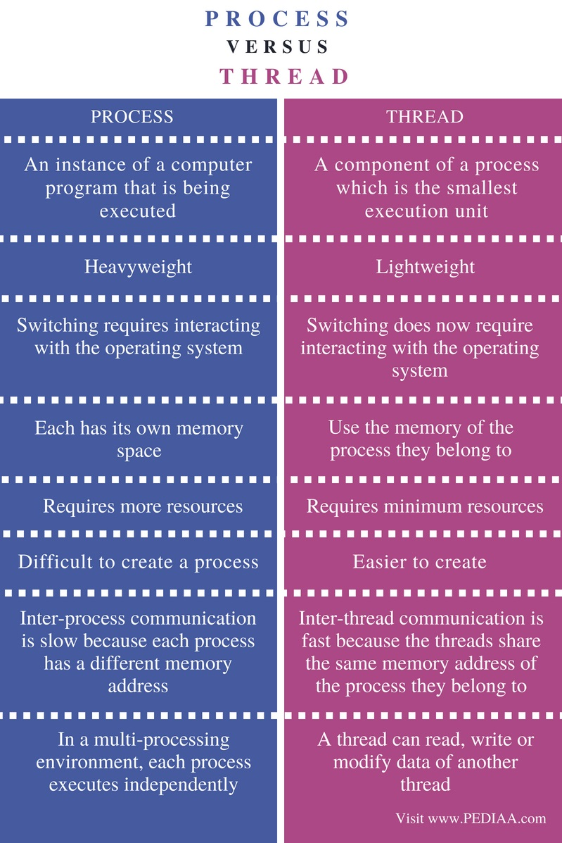

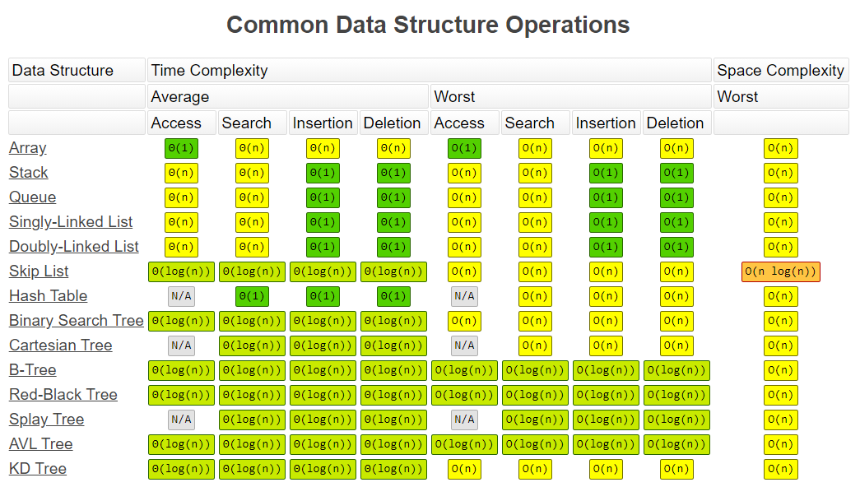

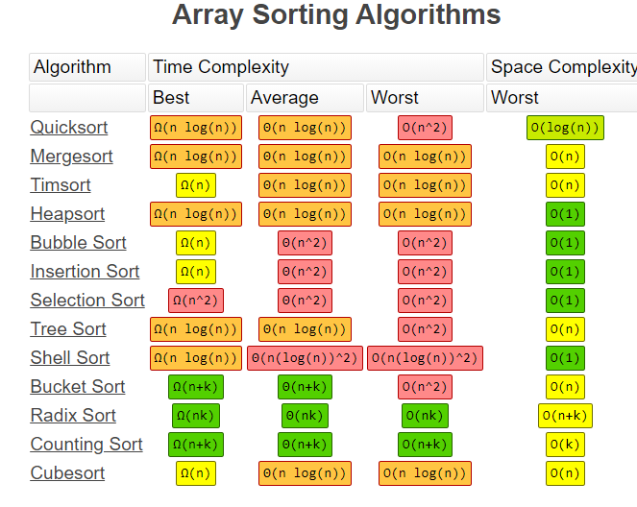

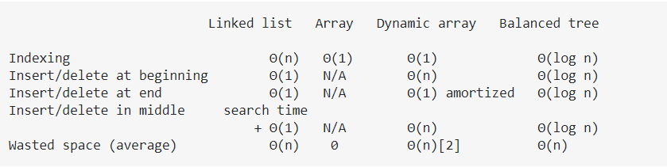

Binary search is **an efficient algorithm for finding an item from a sorted list of items**. It works by repeatedly dividing in half the portion of the list that could contain the item, until you've narrowed down the possible locations to just one.

[Counting sort](http://en.wikipedia.org/wiki/Counting_sort) is a sorting technique based on keys between a specific range. It works by counting the number of objects having distinct key values (kind of hashing). Then doing some arithmetic to calculate the position of each object in the output sequence.

